

2026-2027

SCHOOL OF COMPUTER
APPLICATIONS
No SQL Project:
Student Management System Using MongoDB

Submitted to: Submitted by:
Mr. Harendra Singh Rajat rai
Department: BCA(DS & AI Roll no:
Date: 30 September (1250258343)

ACKNOWLEDGEMENT

I would like to express my sincere gratitude to Mr. Harendra Singh, my project guide, for his valuable guidance, support, and encouragement throughout the development of this project.
I am thankful to BBD University, School of Computer Applications for providing me with the opportunity to work on the “Student Management System Using MongoDB.” This project helped me understand the practical use of MongoDB, NoSQL database concepts, data management, and CRUD operations for managing student records efficiently.
I would also like to thank my teachers for their continuous support and motivation during the completion of this project.
INTRODUCTION
MongoDB is a popular NoSQL database management system that stores data in the form of flexible documents. Unlike traditional relational databases, MongoDB does not require data to be stored in fixed rows and columns.
In this project, a Student Management System has been developed using MongoDB. The database stores information about students such as roll number, name, age, course, marks, and department.
Various MongoDB operations have been performed on the student data, including inserting, displaying, updating, deleting, sorting, filtering, counting, and searching records. Different query operators such as $eq, $gt, $lt, $gte, and $lte have also been used to demonstrate data filtering and comparison.
The project helps in understanding the practical use of NoSQL databases and MongoDB for managing student records efficiently.

1.CREATE DATABASE
MongoDB Query:
Use Student
Explanation: Creates or switches to the Student database.
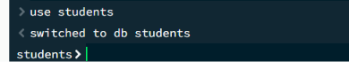
2. CREATE COLLECTION
MongoDB Query:
db. create Collection(“students”)
Explanation: Creates a collection named students.
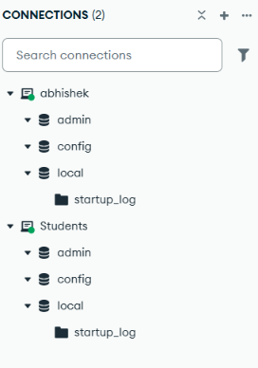

3. INSERT 50 STUDENTS
MongoDB Query:
Db.students.insertMany([
{rollNumber:"CSE001", name:"Abhishek", department:"CSE", marks:85, skills:["Java","MongoDB","AI"]},
{rollNumber:"CSE002", name:"Rahul", department:"CSE", marks:78, skills:["Python","AI"]},
{rollNumber:"ME001", name:"Neha", department:"ME", marks:65, skills:["AutoCAD","Python"]},
{rollNumber:"CSE003", name:"Rohit", department:"CSE", marks:72, skills:["Python","AI"]},
{rollNumber:"IT001", name:"Priya", department:"IT", marks:91, skills:["Java","SQL"]},
{rollNumber:"ECE001", name:"Aman", department:"ECE", marks:67, skills:["C","Arduino"]},
{rollNumber:"CSE004", name:"Anjali", department:"CSE", marks:88, skills:["Python","ML"]},
{rollNumber:"ME002", name:"Vikas", department:"ME", marks:59, skills:["AutoCAD","C"]},
{rollNumber:"IT002", name:"Pooja", department:"IT", marks:76, skills:["Java","SQL"]},
{rollNumber:"CSE005", name:"Karan", department:"CSE", marks:82, skills:["Java","AI"]},

{rollNumber:"CSE006", name:"Sneha", department:"CSE", marks:94, skills:["Python","ML"]},
{rollNumber:"ECE002", name:"Arjun", department:"ECE", marks:69, skills:["C","Java"]},
{rollNumber:"IT003", name:"Simran", department:"IT", marks:81, skills:["Python","SQL"]},
{rollNumber:"ME003", name:"Nikhil", department:"ME", marks:73, skills:["AutoCAD","C"]},
{rollNumber:"CSE007", name:"Kavita", department:"CSE", marks:87, skills:["Java","MongoDB"]},
{rollNumber:"ECE003", name:"Mohit", department:"ECE", marks:62, skills:["C","Arduino"]},
{rollNumber:"IT004", name:"Riya", department:"IT", marks:90, skills:["Python","AI"]},
{rollNumber:"ME004", name:"Sahil", department:"ME", marks:55, skills:["AutoCAD","C"]},
{rollNumber:"CSE008", name:"Muskan", department:"CSE", marks:79, skills:["Java","Python"]},
{rollNumber:"IT005", name:"Deepak", department:"IT", marks:84, skills:["SQL","Java"]},

{rollNumber:"ECE004", name:"Shivam", department:"ECE", marks:71, skills:["C","Python"]},
{rollNumber:"CSE009", name:"Nisha", department:"CSE", marks:89, skills:["AI","ML"]},
{rollNumber:"ME005", name:"Varun", department:"ME", marks:64, skills:["AutoCAD","Python"]},
{rollNumber:"IT006", name:"Komal", department:"IT", marks:92, skills:["Python","SQL"]},
{rollNumber:"CSE010", name:"Yash", department:"CSE", marks:77, skills:["Java","AI"]},
{rollNumber:"CSE011", name:"Sakshi", department:"CSE", marks:83, skills:["Python","ML"]},
{rollNumber:"ECE005", name:"Harsh", department:"ECE", marks:68, skills:["C","Arduino"]},
{rollNumber:"IT007", name:"Payal", department:"IT", marks:86, skills:["Java","SQL"]},
{rollNumber:"ME006", name:"Akash", department:"ME", marks:74, skills:["AutoCAD","C"]},
{rollNumber:"CSE012", name:"Tanya", department:"CSE", marks:95, skills:["AI","Python"]},

{rollNumber:"ECE006", name:"Ravi", department:"ECE", marks:61, skills:["C","Java"]},
{rollNumber:"IT008", name:"Ayesha", department:"IT", marks:88, skills:["Python","SQL"]},
{rollNumber:"ME007", name:"Manish", department:"ME", marks:70, skills:["AutoCAD","C"]},
{rollNumber:"CSE013", name:"Isha", department:"CSE", marks:93, skills:["AI","ML"]},
{rollNumber:"IT009", name:"Varsha", department:"IT", marks:80, skills:["Java","Python"]},
{rollNumber:"ECE007", name:"Suresh", department:"ECE", marks:58, skills:["C","Arduino"]},
{rollNumber:"CSE014", name:"Megha", department:"CSE", marks:85, skills:["MongoDB","Python"]},
{rollNumber:"ME008", name:"Rakesh", department:"ME", marks:66, skills:["AutoCAD","C"]},
{rollNumber:"IT010", name:"Shreya", department:"IT", marks:91, skills:["Python","AI"]},
{rollNumber:"CSE015", name:"Tarun", department:"CSE", marks:79, skills:["Java","SQL"]},

{rollNumber:"ECE008", name:"Gaurav", department:"ECE", marks:63, skills:["C","Python"]},
{rollNumber:"CSE016", name:"Divya", department:"CSE", marks:89, skills:["AI","Python"]},
{rollNumber:"ME009", name:"Naveen", department:"ME", marks:75, skills:["AutoCAD","C"]},
{rollNumber:"IT011", name:"Pallavi", department:"IT", marks:96, skills:["Python","ML"]},
{rollNumber:"CSE017", name:"Kunal", department:"CSE", marks:82, skills:["Java","MongoDB"]},
{rollNumber:"ECE009", name:"Swati", department:"ECE", marks:73, skills:["C","Arduino"]},
{rollNumber:"IT012", name:"Raj", department:"IT", marks:87, skills:["SQL","Python"]},
{rollNumber:"ME010", name:"Jyoti", department:"ME", marks:69, skills:["AutoCAD","Python"]},
{rollNumber:"CSE018", name:"Vivek", department:"CSE", marks:90, skills:["AI","ML"]},
{rollNumber:"IT013", name:"Monika", department:"IT", marks:78, skills:["Java","SQL"]}
])

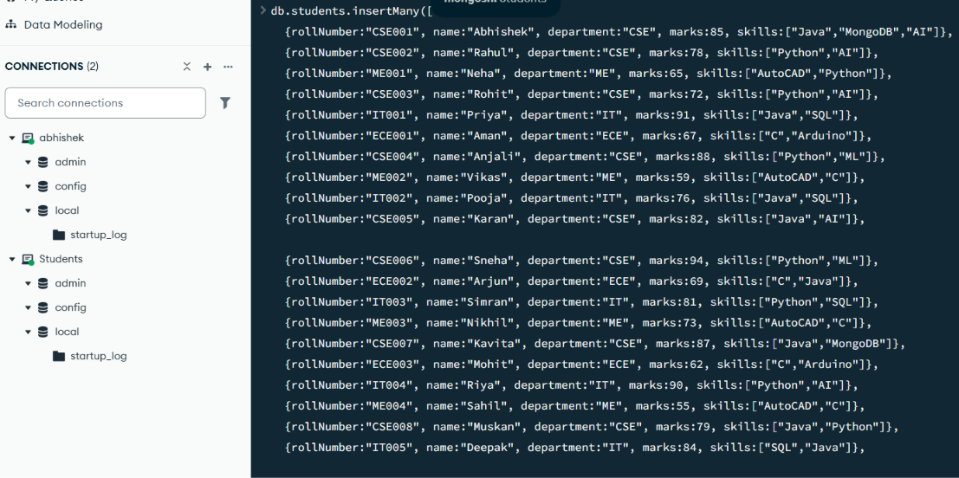
Explanation: Inserts multiple student documents into the collection.
4. DISPLAY ALL STUDENTS
MongoDB Query:
db. students .find()
Explanation: Retrieves documents from the students collection.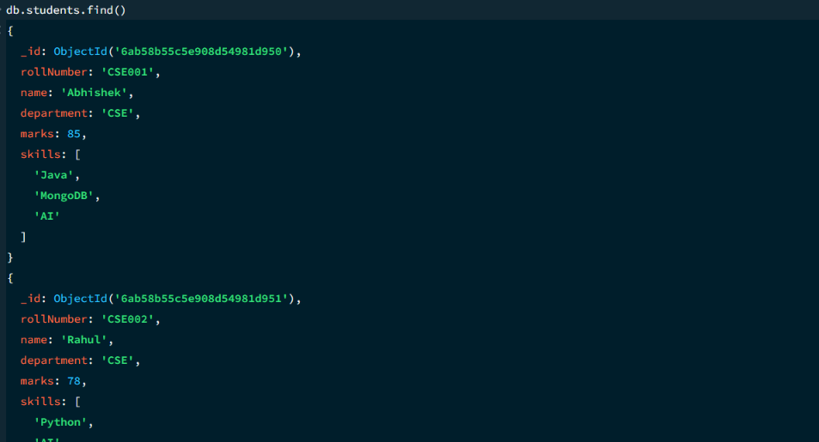
5.GREATER THAN - $gt
MongoDB Query:

db. students.find({marks: {$gt:85}})
Explanation: Finds students whose marks are greater than 85.
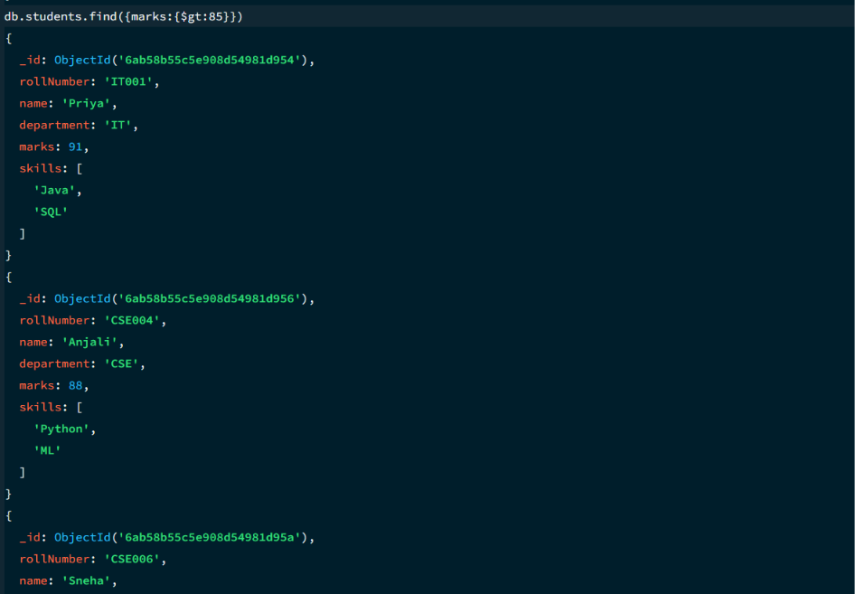

6. LESS THAN - $lt
MongoDB Query:

db. students. find({marks: {$lt: 70}})
Explanation:Finds students whose marks are less than 70.
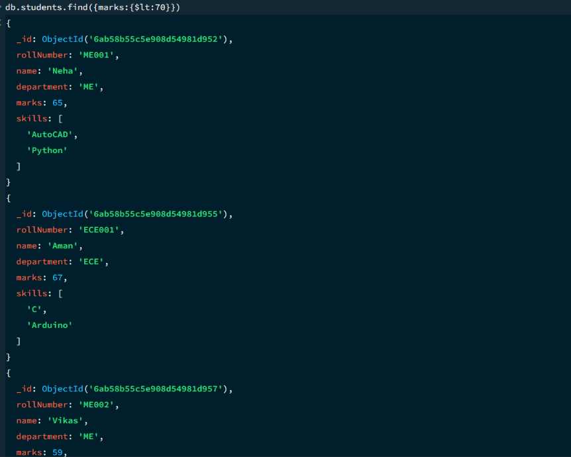
7. EQUAL TO - $eq
MongoDB Query:
Db. students. Find({marks: {$eq: 90 }})
Explanation:Finds students whose marks are exactly 90

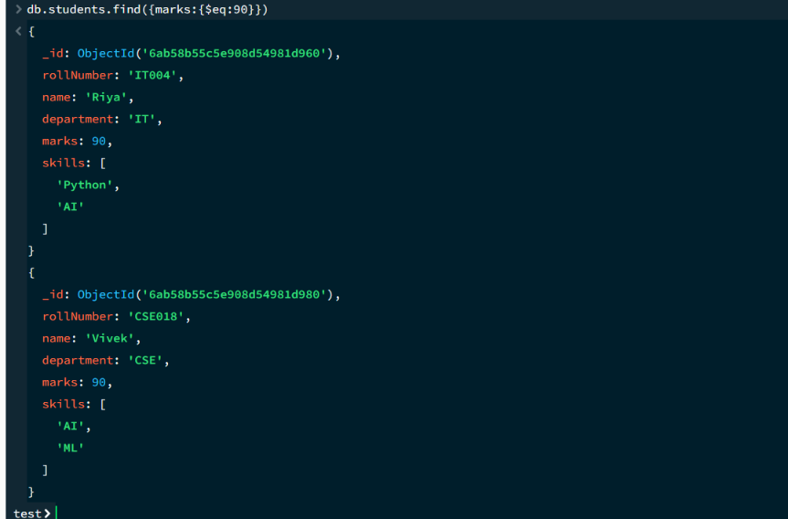

8.GREATER THAN EQUAL -$gte
MongoDB Query:
db .students. find(marks:{$gte:90}})
Explanation: Finds students whose marks are 90 or above.
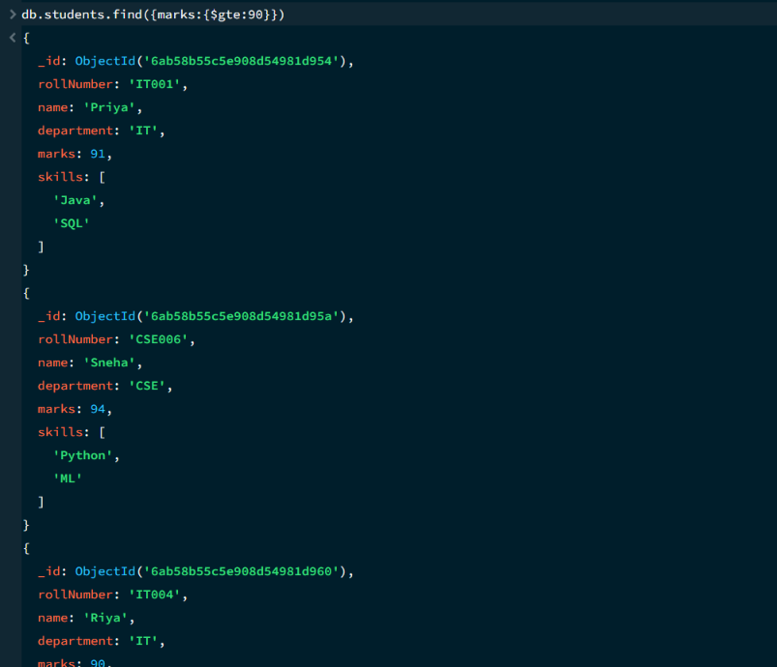

9.LESS THAN EQUAL TO - $lte
MongoDB Query:
db.students.find({marks:{$lte:70}})
Explanation: Finds students whose marks are 70 or below.

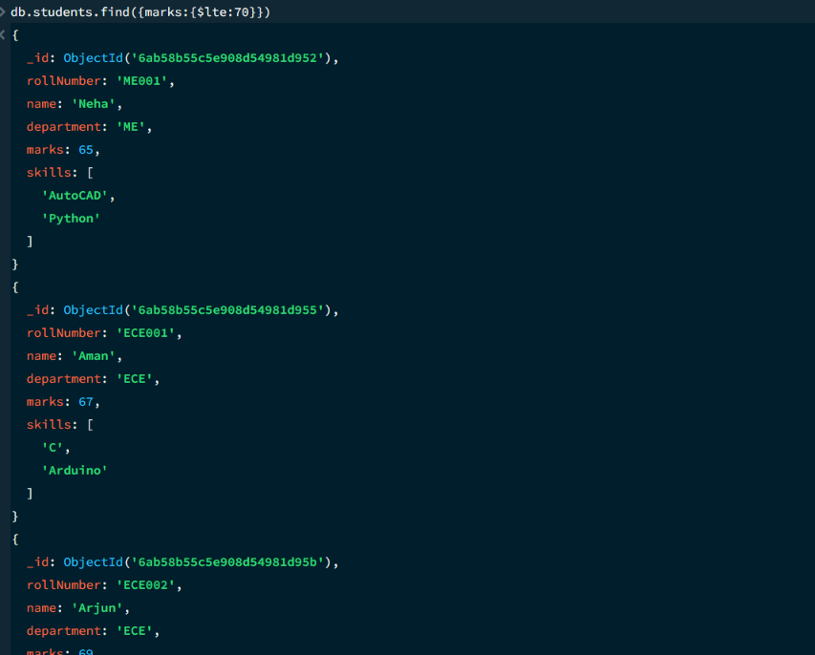
10. UPDATE OPERATION
MongoDB Query:
db.students.updateOne(
{rollNumber:'ECE008'},
{$set:{marks:87}})
Explanation: Updates the marks to 87 of the student with rollNumber ‘ECE008’.
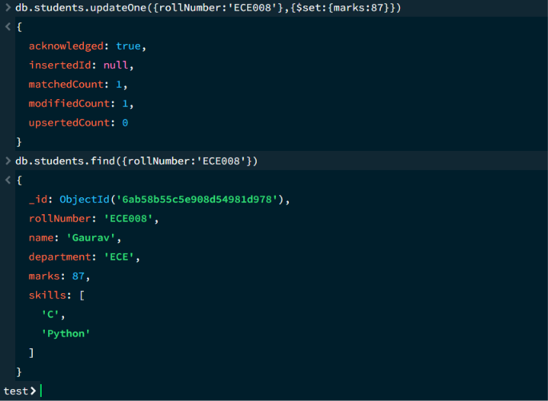
11.DELETE ONE OPERATION
MongoDB Query:
db.students.deleteOne({rollNumber: "ME001"})
Explanation: Delete one document matching rollNumber:”ME001”.
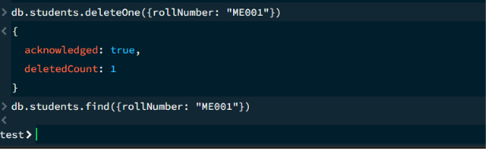

11.DELETE MANY OPERATION
MongoDB Query:
db.students.deleteMany({
marks:{$lt:60}
})
Explanation: Deletes all students having marks below 60.
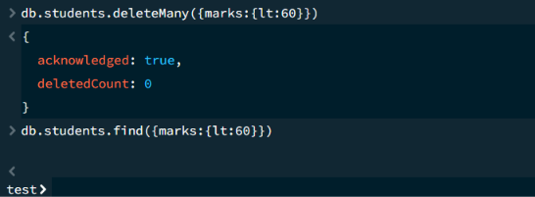
13. AND OPERATION - $and
MongoDB Query:
db.students.find({
$and: [
{ marks: { $gt: 80 } },
{ department: "CSE" } ]})
Explanation: Finds students satisfying both conditions.
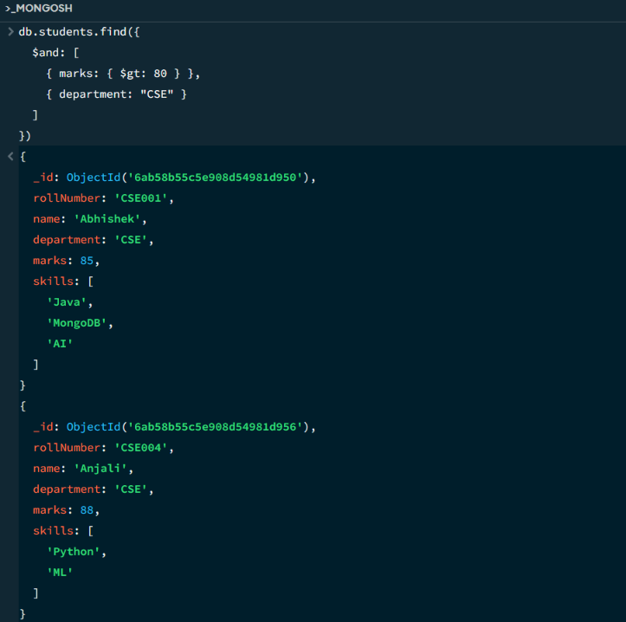
14. OR OPERATION - $or
MongoDB Query:
db.students.find({
$or: [
{ marks: { $gt: 80 } },
{ department: "CSE" }
]})
Explanation: Finds students with marks greater than 80 or from the CSE department.
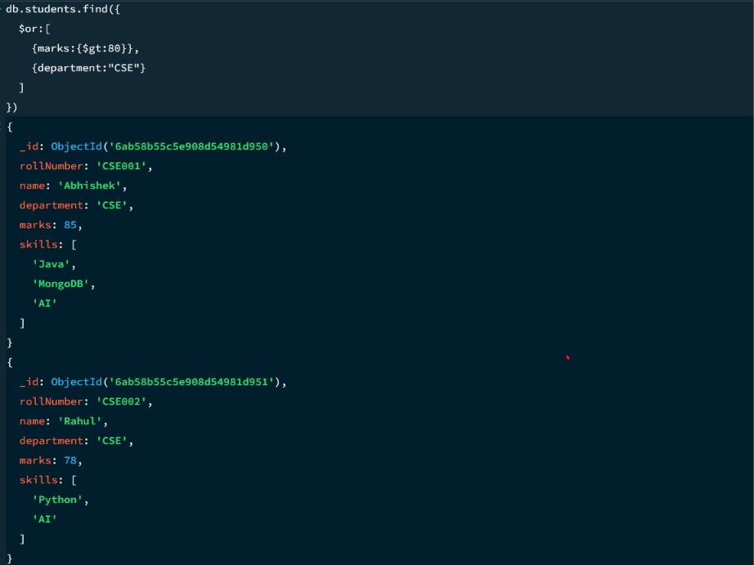
15. SORT OPERATION
A.MongoDB Query:
db. students. find(). sort({marks : 1})
Explanation: This operation sorts the students according to their marks in ascending order, from lowest to highest.
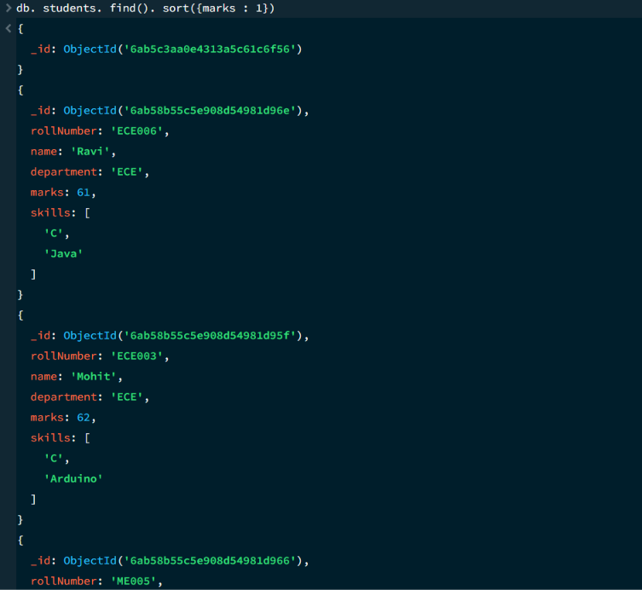
B.MongoDB Query:
db. students. find(). sort({marks : -1})
Explanation: This operation sorts the students according to their marks in descending order, from highest to lowest.
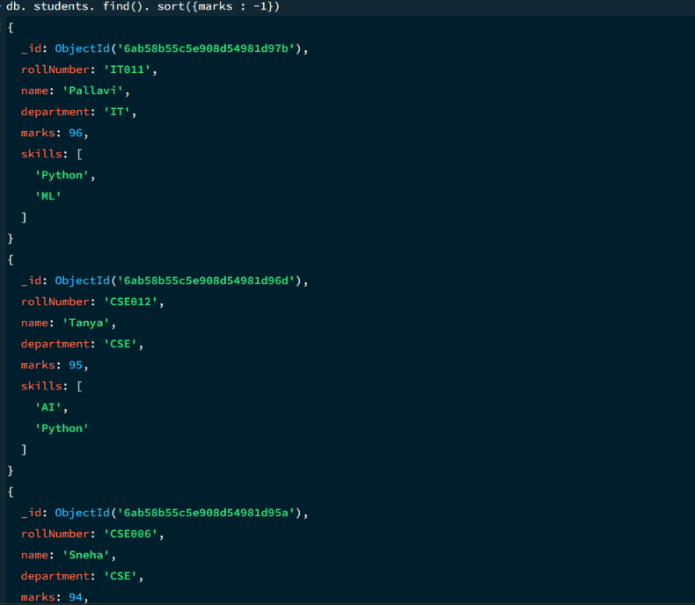
16. LIMIT OPERATION
MongoDB Query:
db. students. find(). limit (5)
Explanation: Displays only the frist five documents.
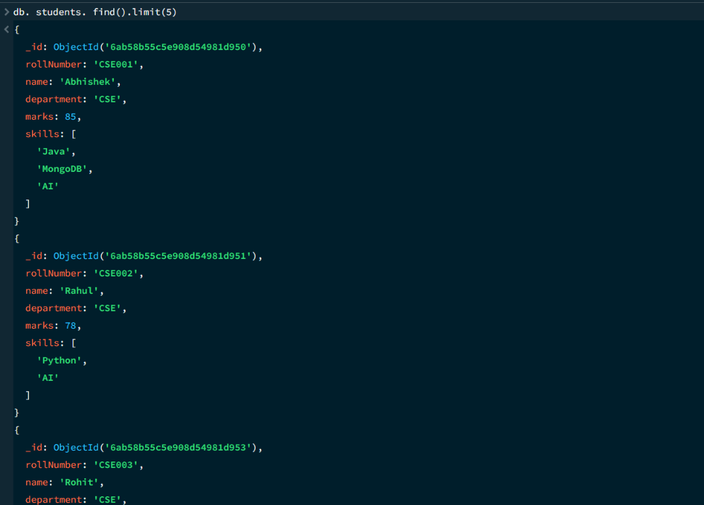

17. SEARCH BY DEPARTMENT
MongoDB Query:
db.students.find({department: "CSE"})
Explanation: Finds students from the CSE department.

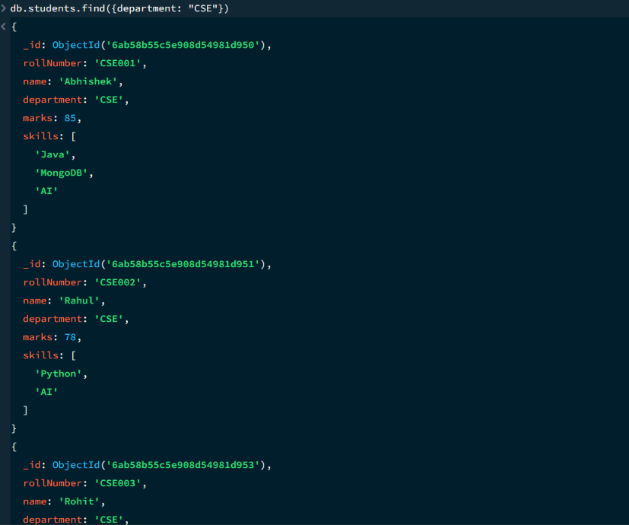

18. COUNT DOCUMENTS
MongoDB Query:
db. students. count Documents ()
Explanation: Counts the total number of students in the collection.
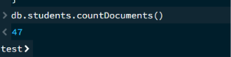

MONGODB OPERATION USED:
- Create Database & Collection
- Insert Documents
- Find / Display Documents
- Comparison Operators — $eq, $gt, $lt, $gte, $lte
- Update Documents — updateOne()
- Delete Documents — deleteOne(), deleteMany()
- Logical Operators — $and, $or
- Sort Operation — Ascending / Descending
- Limit Operation — limit()
- Search Operation — Search by Department
- Count Documents — countDocuments()
CONCLUSION

